ADEI Learning Participant Guide - Session #3
January 10 & 11, 2023

DISCONNECT from Inequitable Practices and Systems:
Explore Strategies to Engage in Productive Conversations About Racial Equity and Use a Design Justice Approach to Identify Opportunities for Organizational Improvement
Table of Contents
Warm Welcome 2
Agenda, Objectives, and Community Agreements 2
Breakout #1: Building Community/ Reflecting on Past Learning 3
Strategies to Engage in Race Conversations 3
Foundational Frameworks 3
Four Zones of Growth 4
Connecting to the Bridge to Practice 6
Breakout #2: Reflecting on the Bridge to Practice 7
Choosing to Engage 7
Speaking Truth for Organizational Improvement 8
Dr. Luvvie Jones 8
Antidotes and Conditions 9
Equity Detours 10
Pacing for Privilege & Deficit Ideology 10
Speaking Truth 11
Design Justice for Organizational Improvement 12
Design Justice 12
Self-Reflection Questions 13
Breakout #3 - Design Approach for Bridge to Practice –Due by Session #4 in February! 13
Optimistic Closure 14
Dr. Kiara Butler 14
Bridge to Practice 14
Head - Heart - Hands Reflection 14
Next Steps 15

Topic | Resources & Notes

Warm Welcome

Agenda, Objectives, and Community Agreements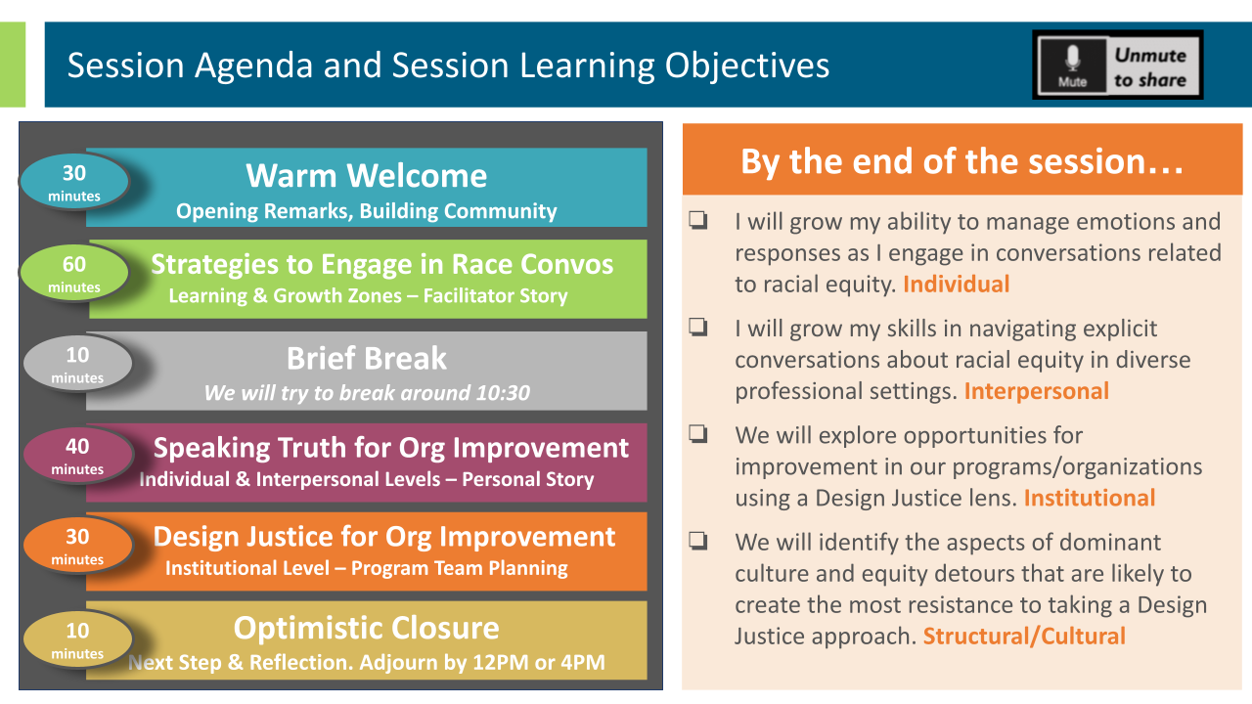
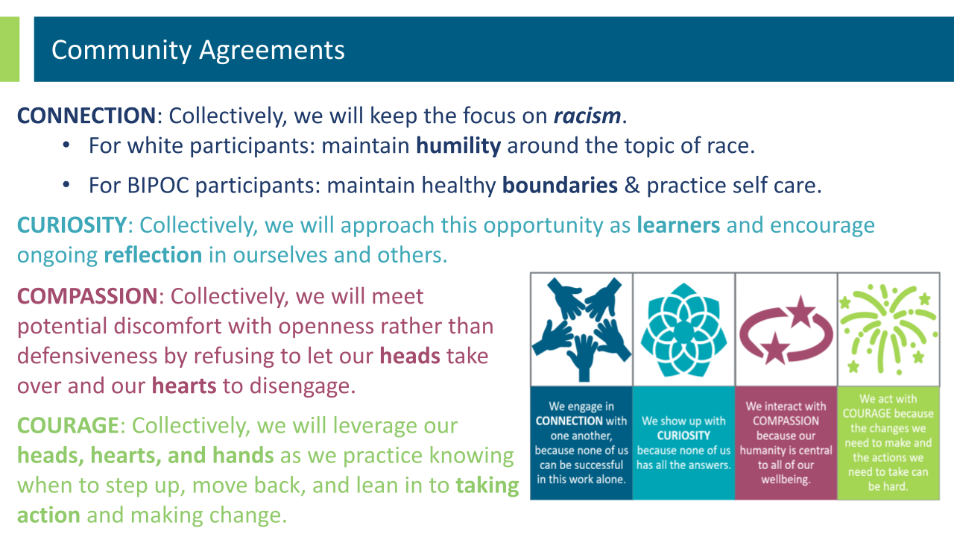
Breakout #1: Building Community/ Reflecting on Past Learning | 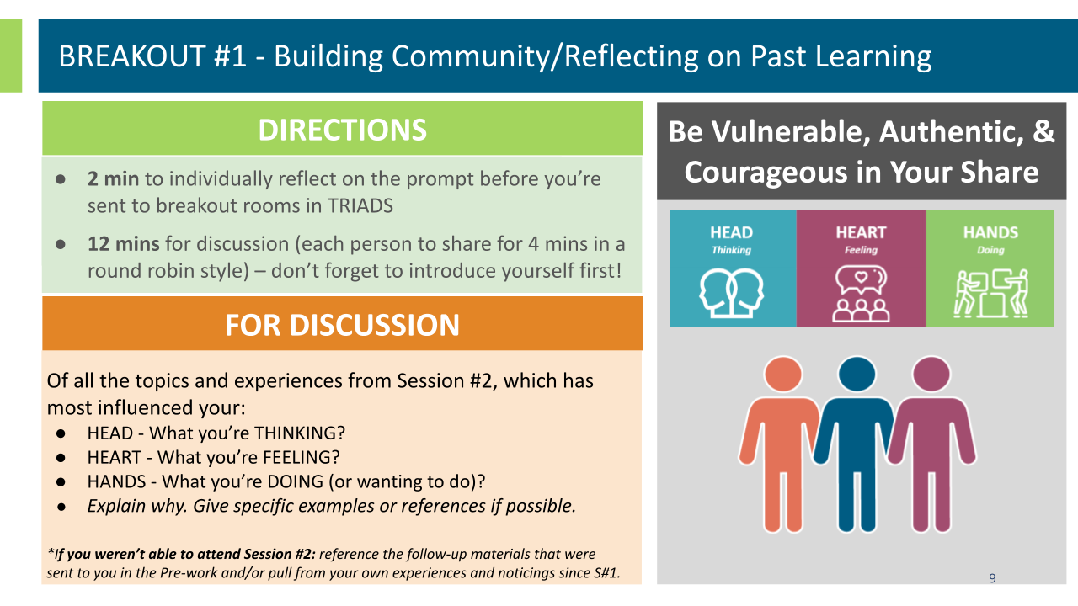

Strategies to Engage in Race Conversations
Foundational Frameworks | 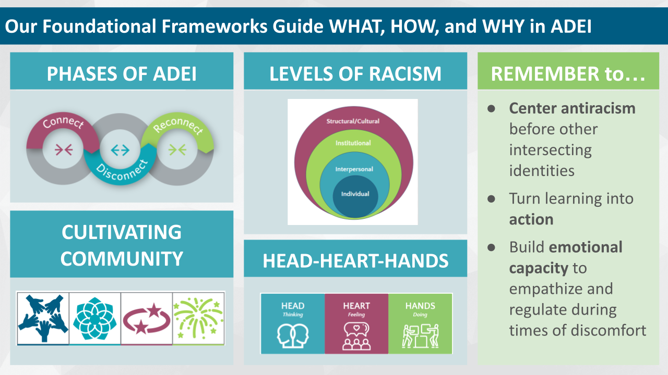
Four Zones of Growth | 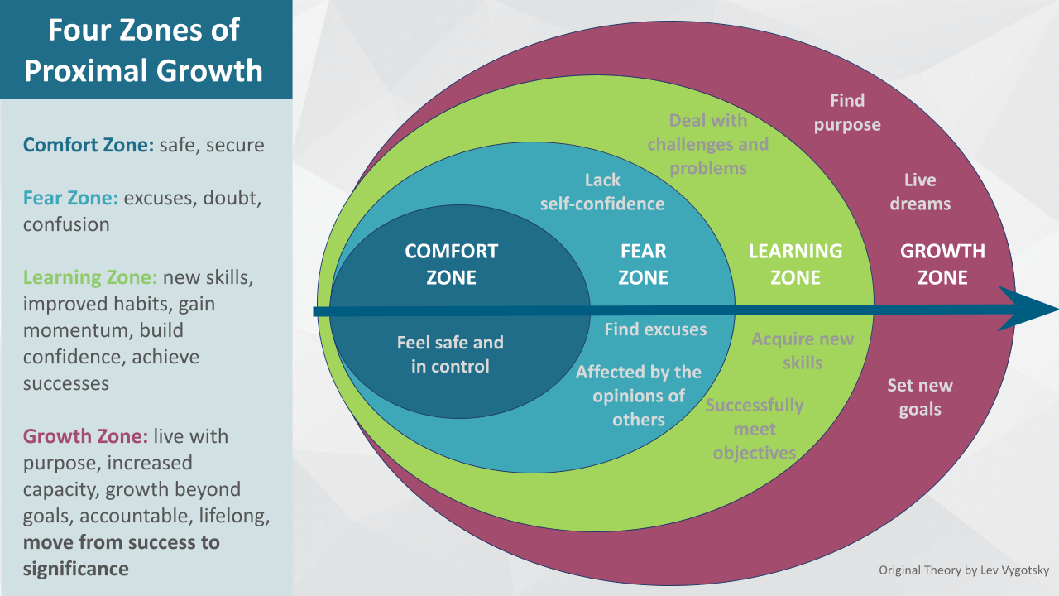  REFLECT on Your Own Zones of Proximal Growth  As you listen to Ian share his personal home improvement journey:  - Where do you see the levels of Proximal Growth showing up?  - COMFORT Zone:  - FEAR Zone:  - LEARNING Zone:  - GROWTH Zone:  - What personal story of your own can you think of here that demonstrates your own brain’s growth?  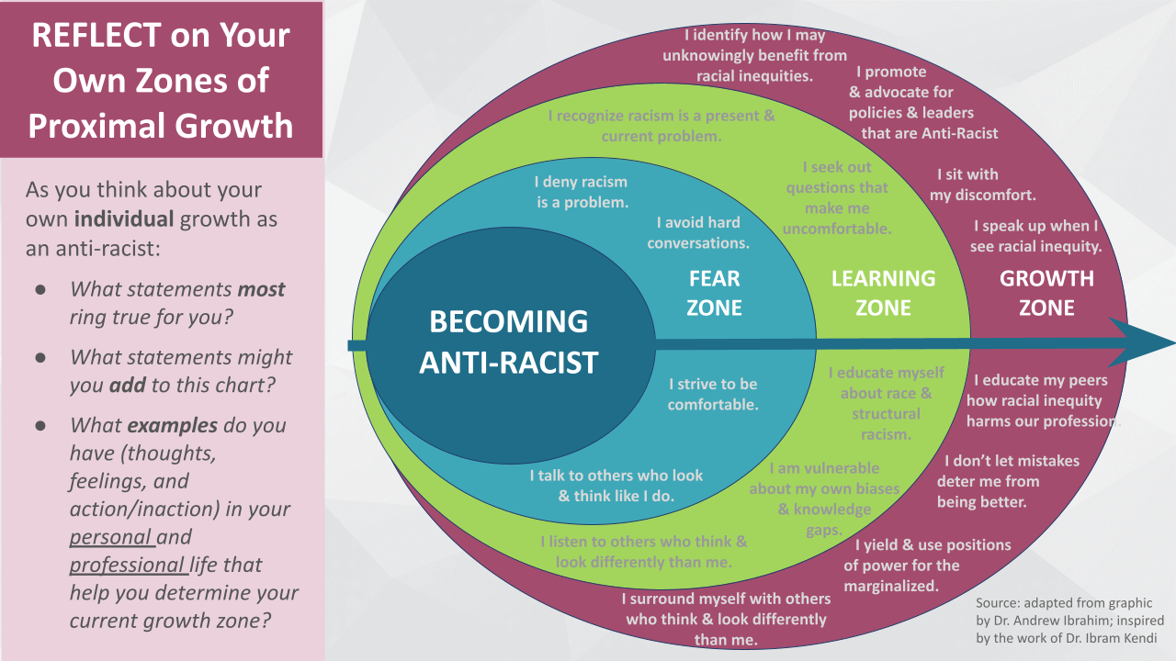  REFLECT on Your Own Zones of Proximal Growth  As you think about your own individual growth as an anti-racist:  - What statements most ring true for you?  - What statements might you add to this chart?  - What examples do you have (thoughts, feelings, and action/inaction) in your personal and professional life that help you determine your current growth zone?
Connecting to the Bridge to Practice | Review of Team Posters to Better Understand Racial Equity Challenges and Their Impacts:  - Access the Posters here  - Posters are organized by one of the three Dominant Culture Characteristics your group was asked to explore.  - Find the trait, then flip through pictures to find your group’s poster.  - With any time remaining, feel free to look through other posters as well.  - Examples of practices, policies, and norms will likely be found in the “Looks like” and “Sounds like” boxes.  NOTES:  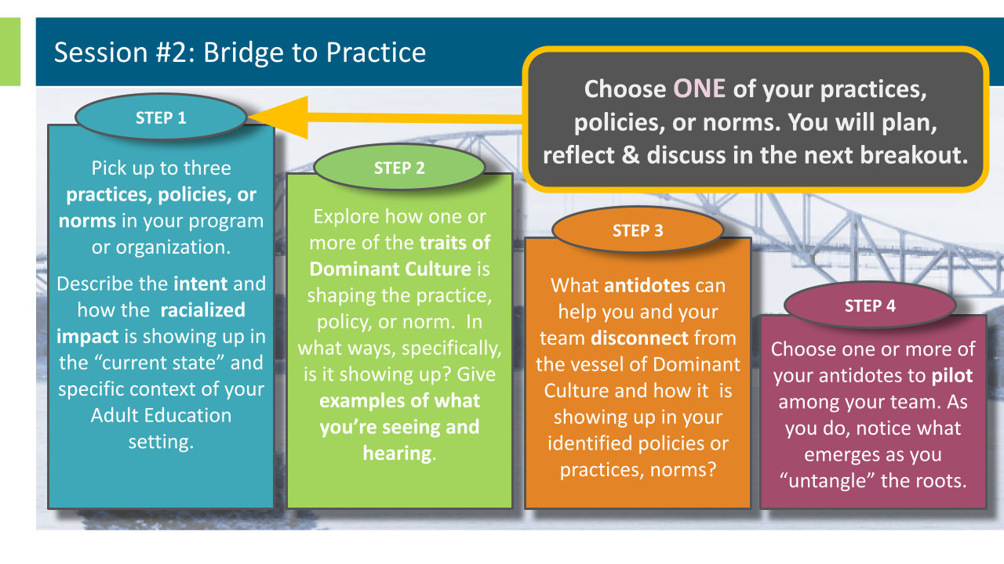  Focus Practice, Policy, or Norm (can be one from your Bridge to Practice –or– one from the Team Posters or Group Discussion):
Breakout #2: Reflecting on the Bridge to Practice | 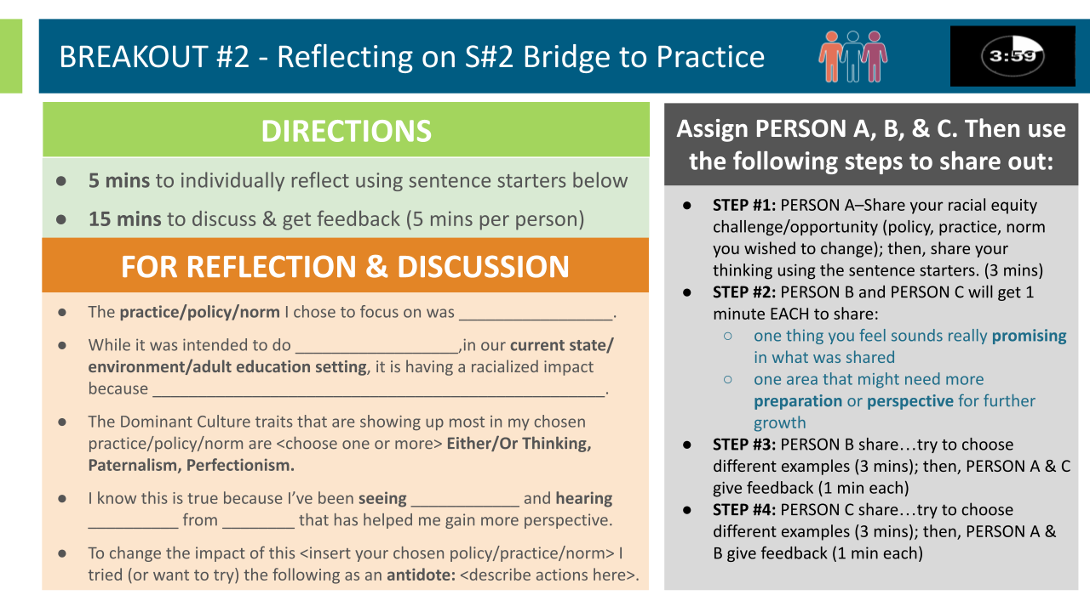  NOTES:
Choosing to Engage | 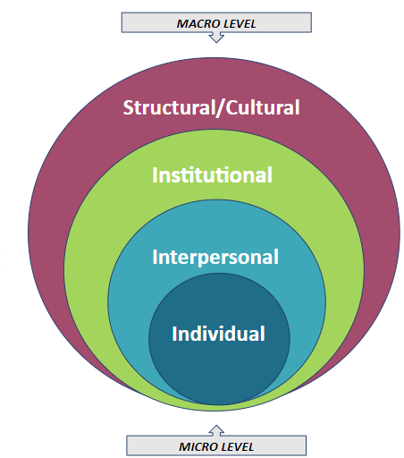  “Organizations often publicly espouse their commitment to external practice without first investing in building internal capacity. Building interpersonal racial capacity at a “micro” level is an essential component and a prerequisite to transforming systems.” – from Humanity Over Comfort (page 92)  - What is Dominant Culture costing you at the moment?  - What benefits come from disconnecting from Dominant Culture?”  “The cost isn’t free… White Supremacy/ [Dominant Culture] comes for us ALL.”  –Olivia A. Cole on "The Truth About White Lies" (https://youtu.be/1skoQ5MK_zU)

Speaking Truth for Organizational Improvement
Dr. Luvvie Jones | Get comfortable with being uncomfortable | Luvvie Ajayi Jones (https://www.youtube.com/watch?v=QijH4UAqGD8&t=331s)  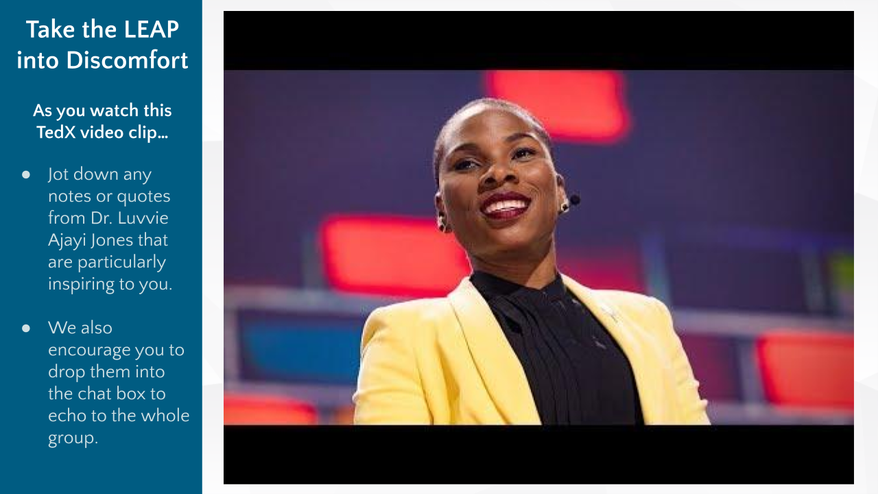  Jot down quotes that resonate with you as the video plays.  Think of a time that you were faced with a moment to “speak truth”:  - What stopped you from “taking the leap?”  - What were your emotions?  - How did it feel in your body?
Antidotes and Conditions | 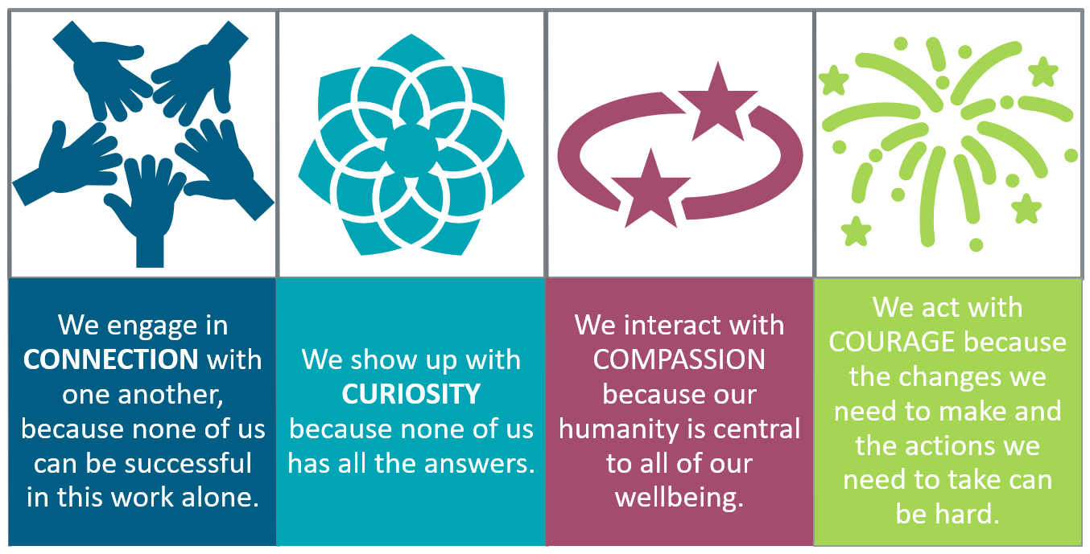  In what ways do you think Connection, Curiosity, Compassion, and Courage can be antidotes to your discomfort in having conversations on race and racial equity?  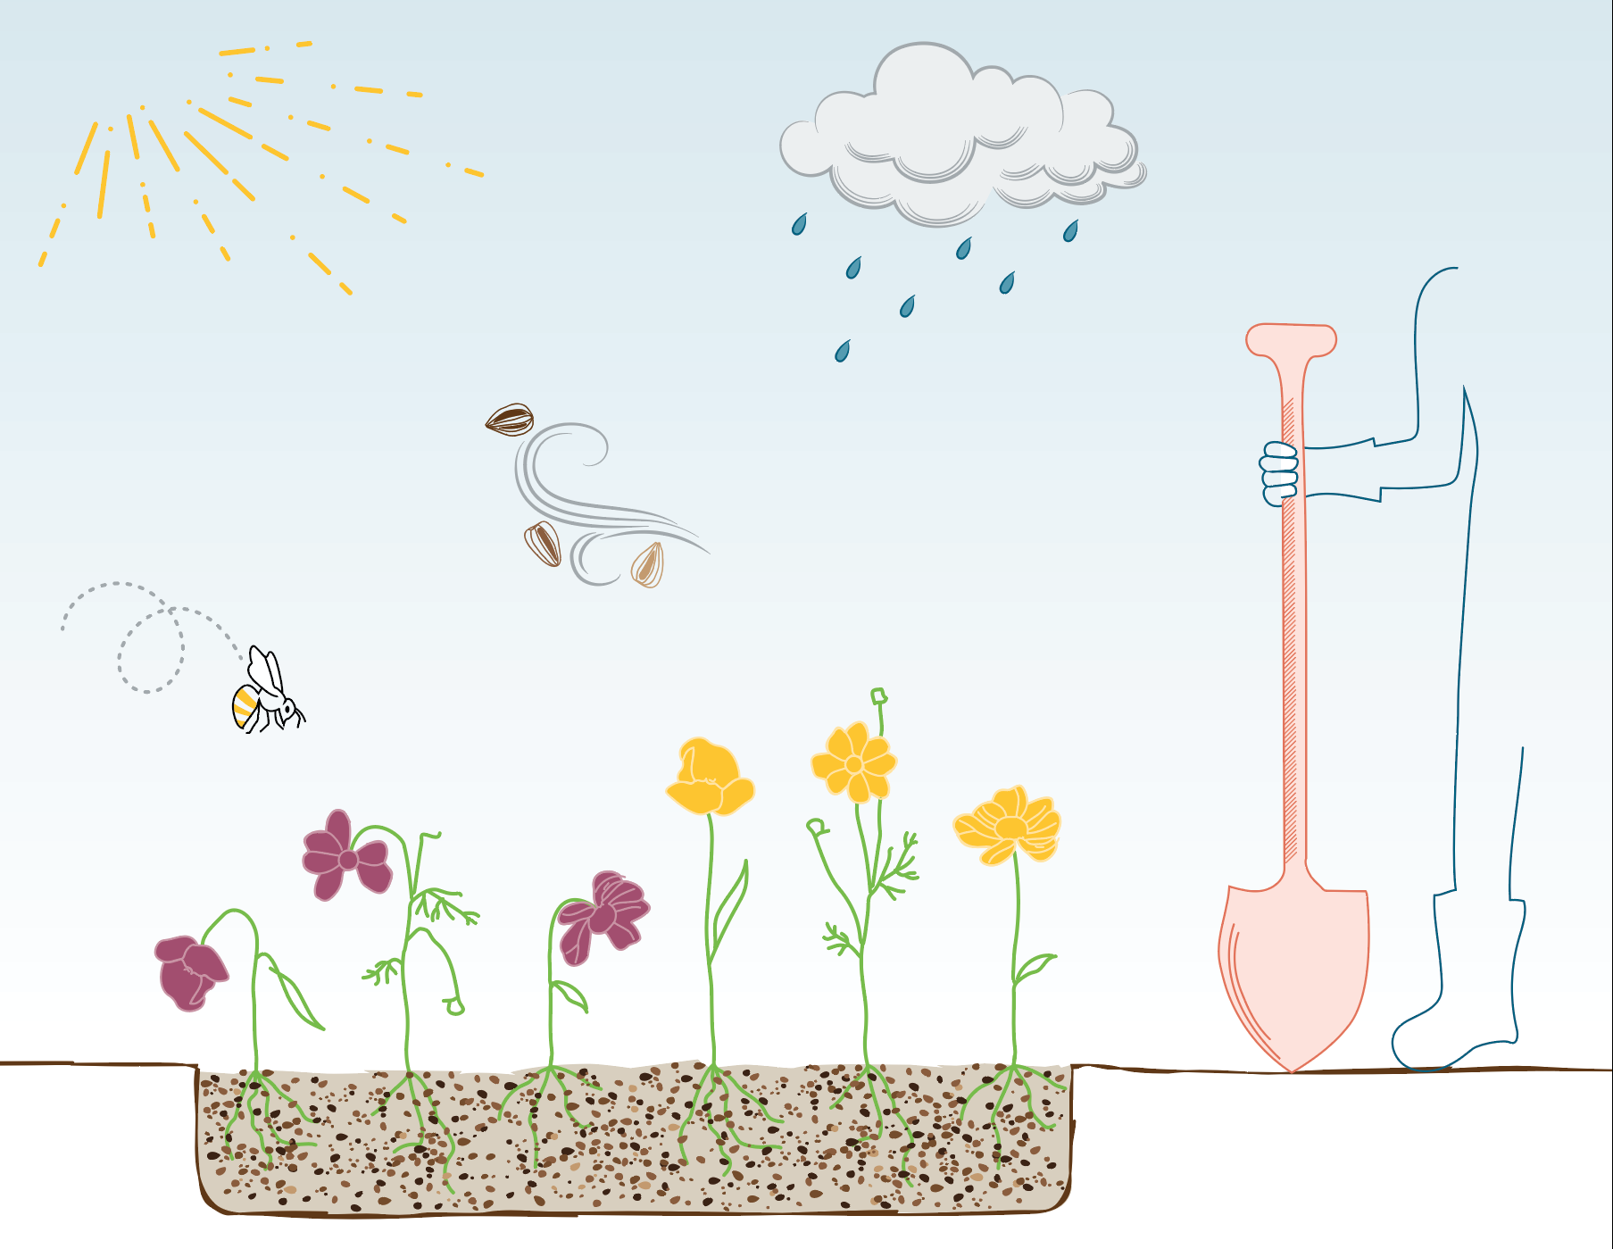  What conditions need to be true in your Professional “Garden” for each of these to help you lean into the discomfort we know is needed to achieve racial equity in our programs & organizations?
Equity Detours | 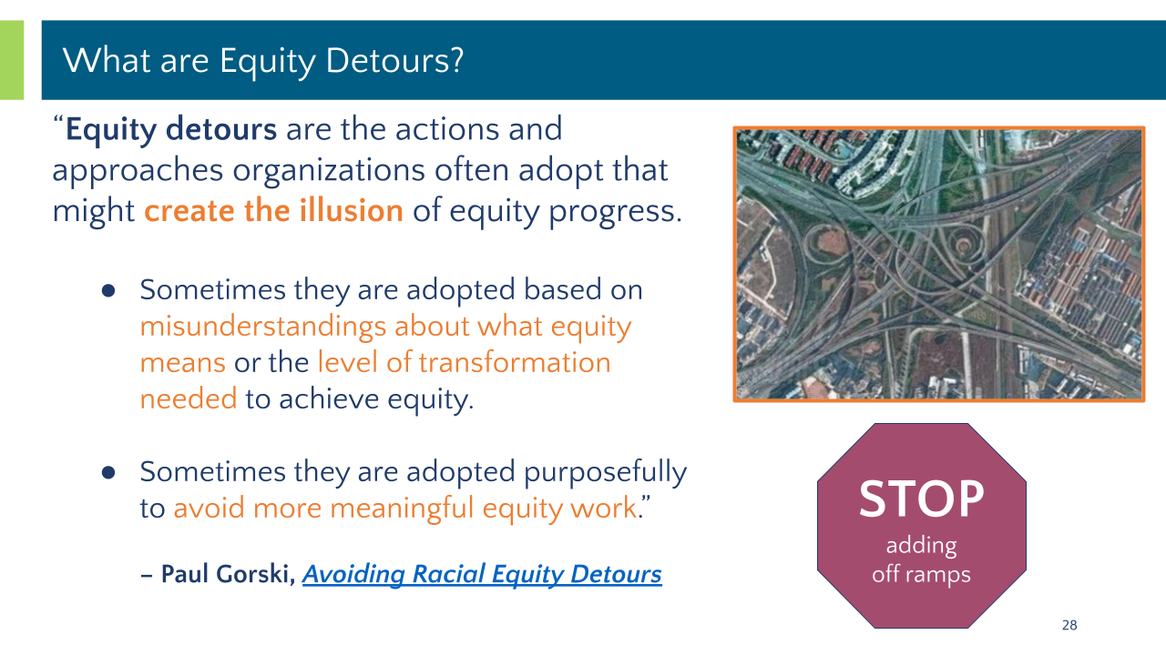  Source: http://www.edchange.org/publications/Avoiding-Racial-Equity-Detours-Gorski.pdf
Pacing for Privilege & Deficit Ideology | 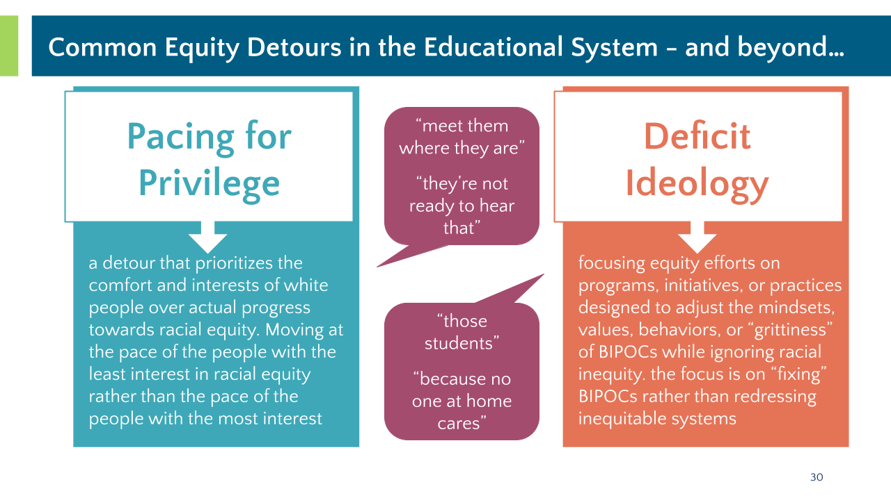
Speaking Truth | 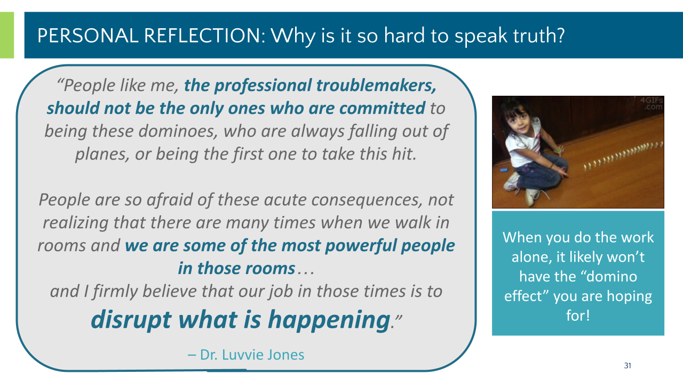  Reflection Questions  - How might my antidote/s lead to equity detours?  - What other possibilities can be antidotes instead?  - How might I “speak truth” (to myself or others) in my effort to avoid these detours?

Design Justice for Organizational Improvement
Design Justice | 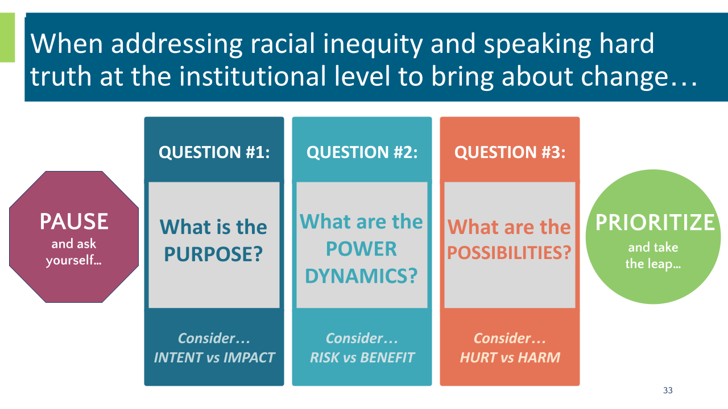  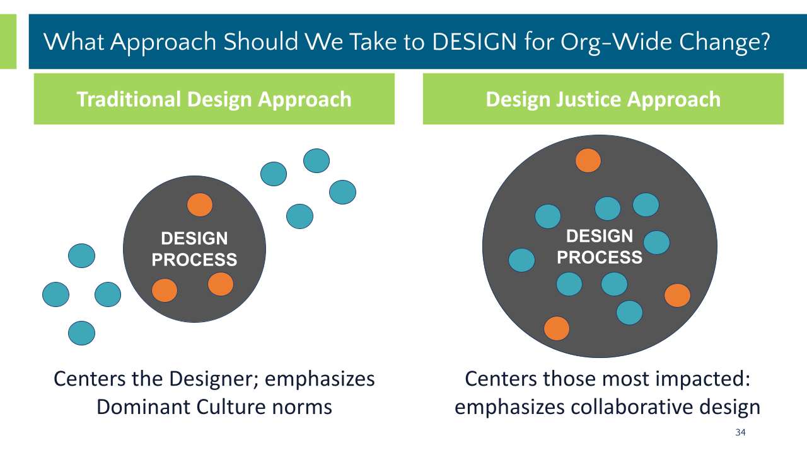  NOTES:
Self-Reflection Questions | 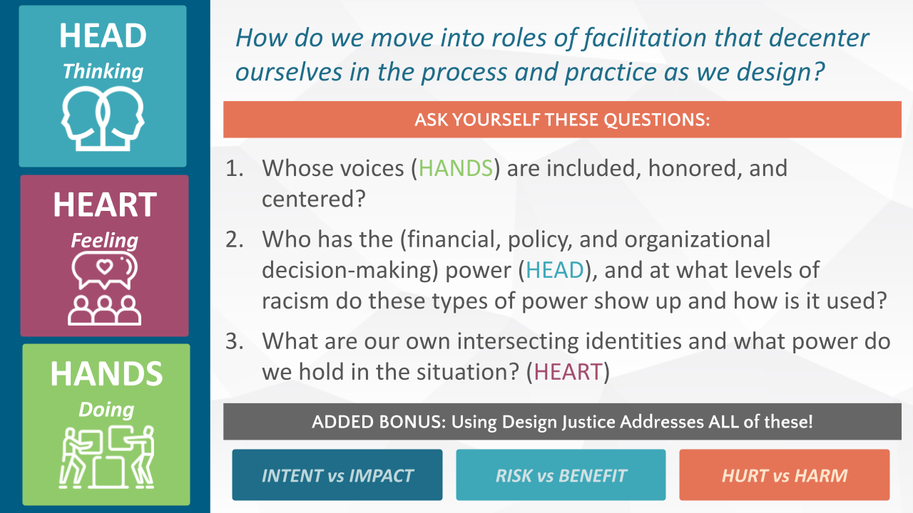
Breakout #3 - Design Approach for Bridge to Practice | 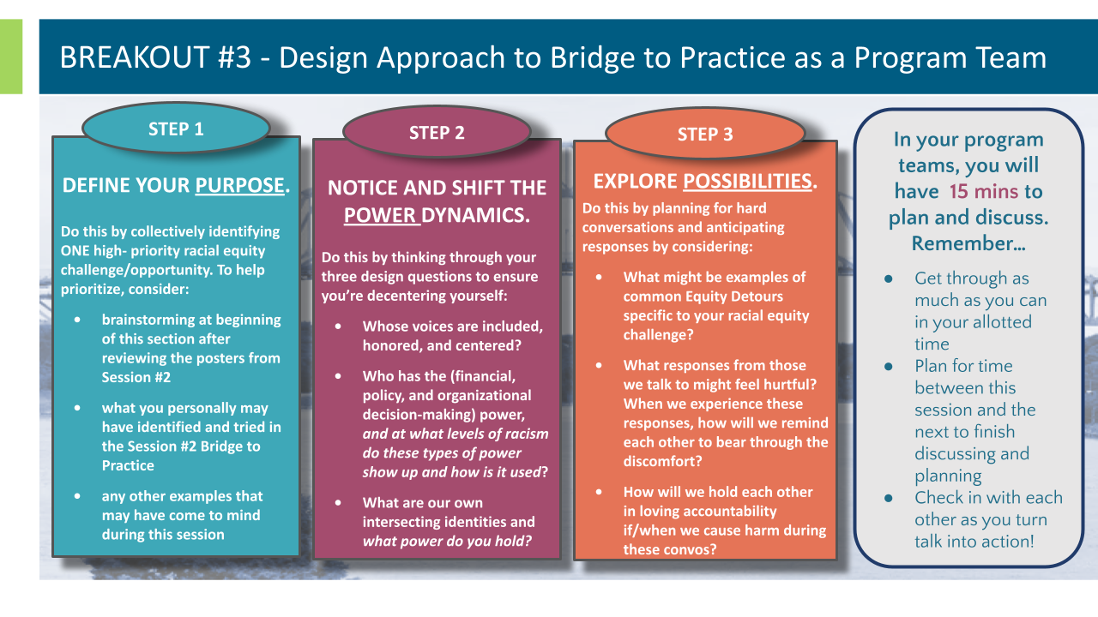  NOTES:

Optimistic Closure
Dr. Kiara Butler | The Untold Truth | Kiara Butler | TEDxProvidence (https://youtu.be/Le9w0C3pJUs)
Bridge to Practice | 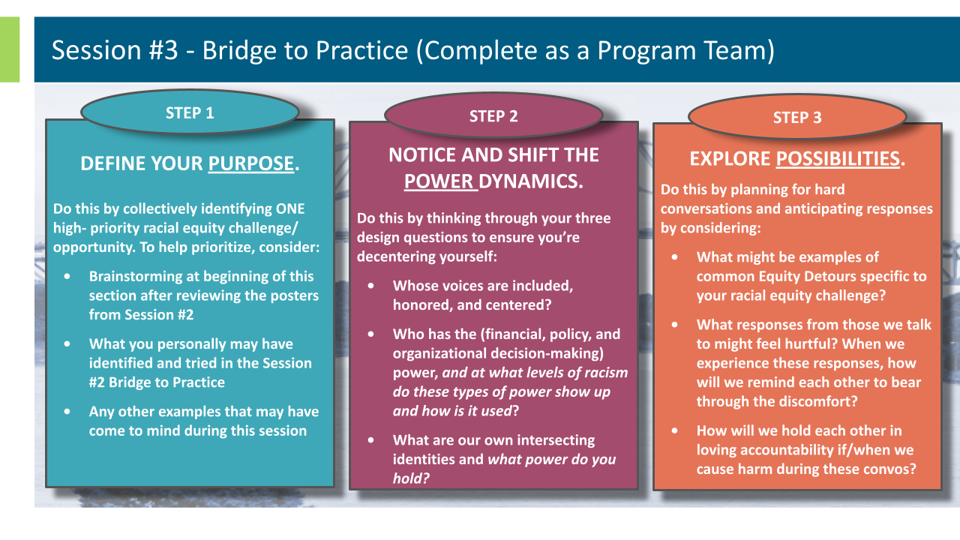
Head - Heart - Hands Reflection | 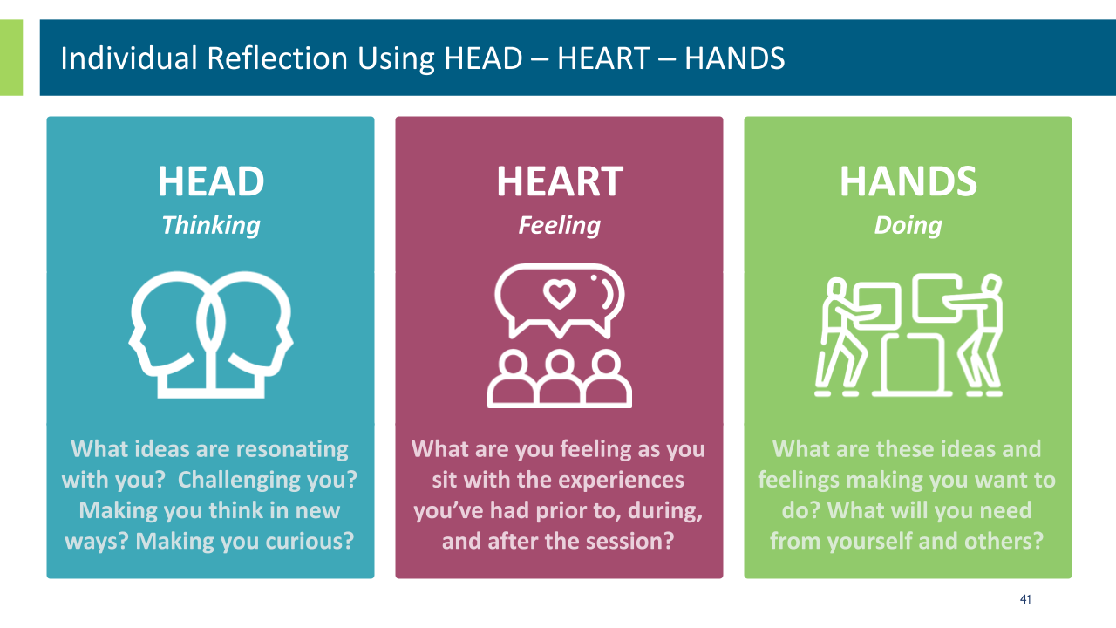
Next Steps | 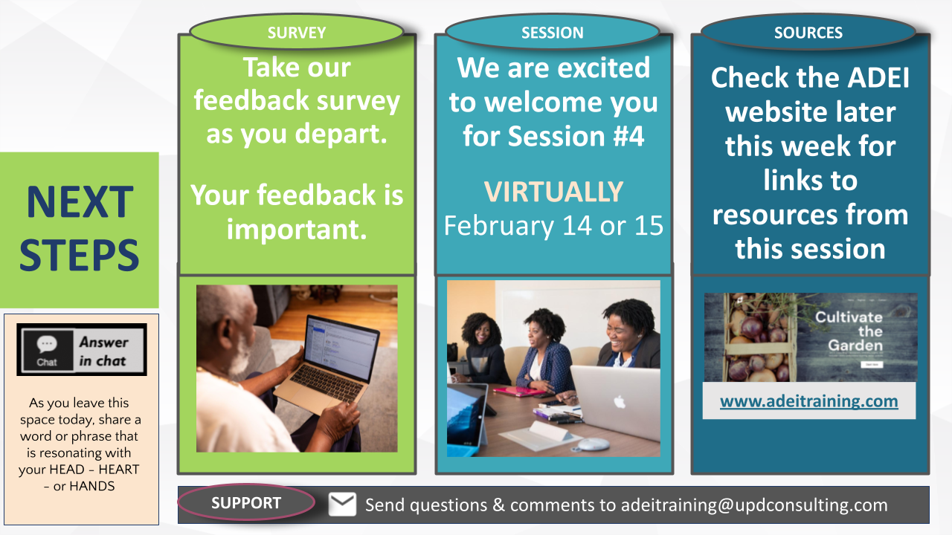  Survey Link (Please complete by end of day today): https://docs.google.com/forms/d/e/1FAIpQLSeSDpr6uKzyxgYlhgeJPnQ5zkuZUvzf64LPyIOK7-2kIG1Hlg/viewform?usp=sf_link
Parking Lot

