Pre-work & Resource Preview -   
Session #3: ADEI Learning Series

January 10 –or– 11, 2023

| **Cohort A**  Tues, Jan 10 (9:00-12:00) | **Cohort B**  Tues, Jan 10 (1:00-4:00) | **Cohort C**  Wed, Jan 11 (9:00-12:00) | **Cohort D**  Wed, Jan 11 (1:00-4:00) |
| --- | --- | --- | --- |
| **On the day/time of your pre-assigned cohort, please access the Zoom link below. You may log in up to 10 minutes prior to the session:** [**https://us06web.zoom.us/j/6474652872?pwd=M2VZLzk2ZjFOcStlLzFFSkdXdE55QT09**](https://us06web.zoom.us/j/6474652872?pwd=M2VZLzk2ZjFOcStlLzFFSkdXdE55QT09)(Passcode: 202223) | | | |

**Welcome**

**After an exciting in-person session in November, we are excited for you to join us virtually next week for Session #3 where we will continue to focus on DISCONNECTing from inequitable practices and systems** by **exploring strategies to engage in productive conversations about racial equity and use a Design Justice approach to identify opportunities for organizational improvement.** While you will receive the full participant guide at the beginning of the session, we wanted to encourage you to preview this information as it will be a useful foundation for the upcoming session content. *This pre-work and preview of resources will take about 30 minutes of your time*.

**Facilitators and Contact Information**

Your facilitators and content creators are excited to welcome you *virtually* to Session#3 in this five-part series. In the meantime, please email us with any questions at: [adeitraining@updconsulting.com](mailto:adeitraining@updconsulting.com).

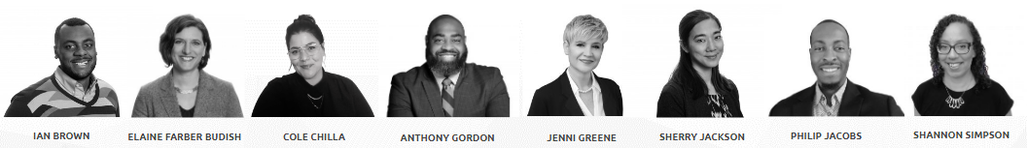

**Engagement and Commitment**

Please take a moment to review the Cultivating Community Framework (CONNECTION, CURIOSITY, COMPASSION, and COURAGE as well as the Community Agreements. In addition to serving as the foundation for our engagement in this series, they will also be an integral part of building skills for having hard conversations on race and racial equity in this session: 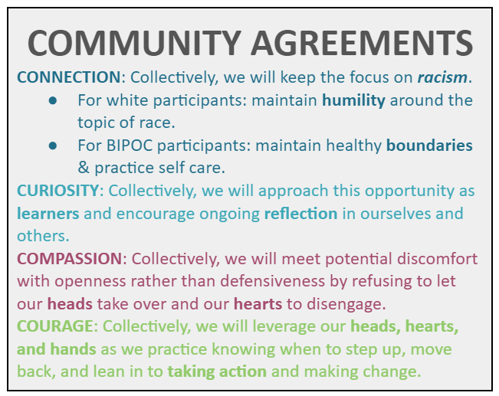

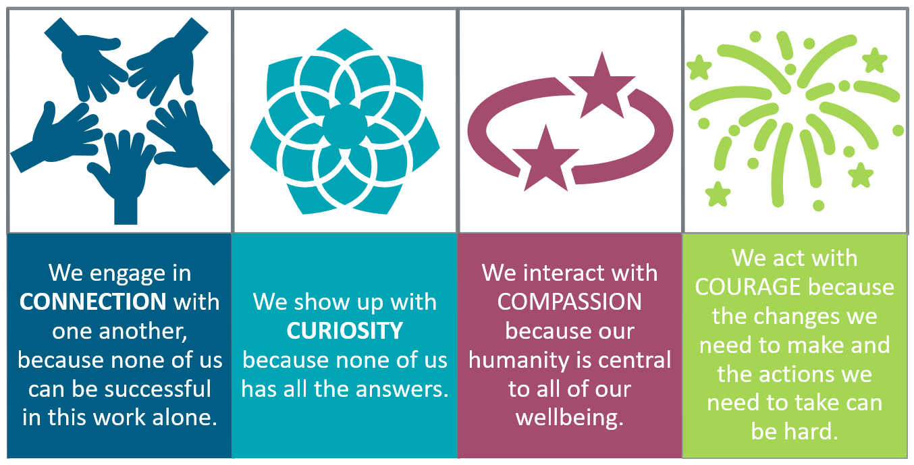

**Session Learning Objectives**

Consider each of the following learning objectives for our upcoming session as we view them through the Four Levels of Racism: Which are you CONNECTED to? Which are you CURIOUS about? Where will you need to tap into your COMPASSION or your COURAGE?

| **In this session, participants will be able to CONNECT to individual and institutional truths by:** |
| --- |
| * I will grow my ability to manage emotions and responses as I engage in conversations related to racial equity. **Individual** * I will grow my skills in navigating explicit conversations about racial equity in diverse professional settings. **Interpersonal** * We will explore opportunities for improvement in our programs/organizations using a Design Justice lens. **Institutional** * We will identify the aspects of dominant culture and equity detours that are likely to create the most resistance to taking a Design Justice approach. **Structural/Cultural** |

**Session Resources and Points to Ponder**

For each of the topics below, we have included select resources that will enable you to make the most of the upcoming ADEI learning session as well as questions to consider as you preview the resources. You can also access these resources and more in your **Participant Guide** on the [**ADEI Website**](http://www.adeitraining.com/) one week prior to the session. It contains all the materials and resources that will be used during the upcoming session.

| **Topic** | **Resources** | **Questions to Consider** |
| --- | --- | --- |
| Shared Language | **It is important to ground ourselves in a shared language and understanding. Therefore, please review:**   * [UPD’s ADEI Glossary](https://docs.google.com/document/d/1oSpNIt1_cgb-xsNBe4LQ9KNb4Deb8vqh4EeV43unSjs/edit?usp=sharing) (2 mins) | For this session, you may want to focus on:   * *Equity Detours, Structural Inequity, White Supremacy* * What terms were new to you? What would you add or modify? |
| Review Important Resources from Session #2 - DISCONNECT– Recognizing the Harmful Impacts of Dominant Culture and Identifying Barriers to Change | **The series builds throughout the sessions. Therefore, it is important to refresh yourself on the following that were used in the last session.** (5 mins to review all)   * [Major Components of Dominant Culture](https://docs.google.com/document/d/1CwC7-7UQH-ccfPxRyEyJhvkDZ-IcORzWygEW9EgfwgA/edit)   + [Team Posters of Dominant Culture Traits](https://drive.google.com/drive/folders/1zfIneJtO2WZMFh-1yurauxhykodSqyet?usp=share_link) * [Cultivating Community](https://drive.google.com/file/d/1XUNpzQ4qIeK1dQOKp88DdYP0vrsypUkS/view?usp=sharing) * [Four Levels of Racism](https://drive.google.com/file/d/19mAP-jwPdmPzfL4TWWjxxORFRY9L1Mz1/view?usp=sharing) * [Garden Analogy Graphic](https://drive.google.com/file/d/1X_y7wmyBEuAW0W_xyGCCw-HheEdEUi9A/view?usp=sharing) | **Content**   * *What content from Session #2 has remained in your mind or in your heart in the past few weeks?* You may find it helpful to review Session #2 materials linked here, located on the ADEI website, as well as the frameworks located to the left:   + [Session Slide Deck](https://drive.google.com/file/d/196oHlx4lCCSJ6_bEhEXykKHXjXIHmRuR/view?usp=sharing)   + [Participant Guide](https://docs.google.com/document/d/16Yg4ugbNR-MFYf3n0fdu978Qe7HisVDgtoW9-wBUdjk/copy) * You will be asked to share your experiences from Session #2 through the [HEAD – HEART – HANDS](https://drive.google.com/file/d/1qcPNxYy-or_j8K7E6QTxT5kBMYe0AIBD/view?usp=sharing) Reflection. * \**NOTE: If you did not attend Session #2, please take extra time to review so that you are ready to fully participate in the initial share out.* |
| Prepare for Session #3 - DISCONNECT– E**xploring** S**trategies to** E**ngage in** P**roductive** C**onversations** A**bout Race &** R**acial** Equity | **Prepare to Share Your Own Lived Experiences** (5 mins)  Because we will be growing our skill sets to have hard conversations about race and racial equity, this session will rely heavily on storytelling–from the facilitators and from each of you sharing your experiences as students and educators. In an effort to decenter Dominant Culture views, voices of students and BIPOC educators will be prioritized in whole group discussions. To help with your ability to be vulnerable, authentic, and courageous in your share, please preview some of the questions (in the right-hand column) that may be asked during the session and consider what your responses might be.  **Brain Science: Zones of Learning and Growth** (5 mins)  We will explore how the brain experiences discomfort and how to help it grow through it. To do so, we will explore Lev Vygotsky’s **Four Zones of Proximal Growth** ([pdf](https://drive.google.com/file/d/11r8CSbyYwhMlXe2ciIjPfAW6kgyoedbS/view?usp=sharing)) and apply it through the **Zones of Becoming Anti-Racist** ([pdf](https://drive.google.com/file/d/1qJF0xHnJg063Mopdwu4v1H4RHKkLekSS/view?usp=sharing)) developed by [Dr. Andew Ibrahim](https://www.surgeryredesign.com/) and inspired by the work of [Dr. Ibram Kendi](https://www.ibramxkendi.com/).  **Preview of Equity Detours** (5 mins)  We will explore and apply each of these concepts deeply in the session. Here is a preview of the definitions:   * **Equity Detours:** Equity detours are the actions and approaches organizations often adopt that might create the illusion of equity progress * **Pacing for Privilege:** a detour that prioritizes the comfort and interests of white people over actual progress towards racial equity. Moving at the pace of the people with the least interest in racial equity rather than the pace of the people with the most interest * **Deficit Ideology:** focusing equity efforts on programs, initiatives, or practices designed to adjust the mindsets, values, behaviors, or “grittiness” of BIPOCs while ignoring racial inequity. The focus is on “fixing” BIPOCs rather than redressing inequitable systems. Language is a common example of this | **Sample Questions You May Be Asked to Share During the Session:**   * What is a recent, personal example of how you have experienced growth? Think about a time that you’ve learned a new skills set, picked up a new trade/hobby, challenged your existing mindsets and beliefs, etc. * What policies, practices, or norms are you seeing (or personally experiencing) that are leading to racial inequities in your adult education setting? (The more real-world, current examples we can share with each other, the better!) * When was a time when you lacked the willingness at that moment to have a necessary yet difficult conversation? What stopped you? What were your emotions at the time? How did it feel in your body? * In what ways do you think **Connection**, **Curiosity**, **Compassion**, and **Courage** can be antidotes to your discomfort in having conversations on race and racial equity? * What conditions need to be true in your Professional “Garden” for each of these to help you lean into the discomfort we know is needed to achieve racial equity in our programs & organizations?   **Four Zones of Learning and Growth**   * Where do you think you are on your current anti-racist journey? How do you know? You may want to consider the questions here.   **Preview of Equity Detours**  **Pacing for Privilege:**   * For **Educator** Participants: *When was a time that you were guilty of moving at the pace of privileged peoples’ comfort (either your own or others’)* * For **Student** Participants: *When was a time that you observed an educator, colleague, or friend move at the pace of those more privileged? How did the experience affect you?*   **Deficit Ideology:**   * For **Educator** Participants: *What are some examples that you have personally said or done (or observed other educators say or do)?* * For **Student** Participants: *What are some examples that you may have personally experienced in the classroom (or other educational setting)?* |
| **Special Request:** We encourage you to practice being brave and speaking from a first person point of view. Personal examples help us collectively build empathy and practice holding discomfort. Facilitators will be modeling this throughout the session. | |
| Bridge to Practice | **Each session introduces a Bridge to Practice that is meant to move the session learning into application.** (5 mins)   * Review the **Bridge to Application** activity and reflect on your implementation efforts. The activity can be found on page 14 of the [Session #2 Participant Guide](https://docs.google.com/document/d/16Yg4ugbNR-MFYf3n0fdu978Qe7HisVDgtoW9-wBUdjk/copy). *Note: this is a link to a forced copy. You may already have a digital copy of the guide with your personal notes saved. Please reference your saved copy if that is the case.* | You will be asked to **share a brief summary of your practice** and to **share your noticings and wonderings from your implementation** of your Bridge to Practice with colleagues. You can prepare ahead of time by thinking about the following:   * *What you found rewarding and challenging about the activity?* * *Where did you notice* ***Dominant Culture*** *characteristics showing up?* * *What emotions came up for you as you were planning and implementing the antidotes in your Bridge to Practice?* |