Pre-work & Resource Preview -   
Session #4: ADEI Learning Series

February 14 –or– 15, 2023

| **Cohort A**  Tues, Feb 14 (9:00-12:00) | **Cohort B**  Tues, Feb 14 (1:00-4:00) | **Cohort C**  Wed, Feb 15(9:00-12:00) | **Cohort D**  Wed, Feb 15 (1:00-4:00) |
| --- | --- | --- | --- |
| **On the day/time of your pre-assigned cohort, please access the Zoom link below. You may log in up to 10 minutes prior to the session:** [**https://us06web.zoom.us/j/6474652872?pwd=M2VZLzk2ZjFOcStlLzFFSkdXdE55QT09**](https://us06web.zoom.us/j/6474652872?pwd=M2VZLzk2ZjFOcStlLzFFSkdXdE55QT09)(Passcode: 202223) | | | |

**Welcome**

**We are excited for you to join us virtually next week for Session #4 where we will enter into our last phase of RECONNECT in the creation of liberatory communities** by **exploring People-Centered Approaches to Addressing Barriers to Racial Equity and to Building Liberatory Communities.** While you will receive the full participant guide at the beginning of the session, we wanted to encourage you to preview this information as it will be a useful foundation for the upcoming session content. *This pre-work and preview of resources will take about 30 minutes of your time*.

**Facilitators and Contact Information**

Your facilitators and content creators are excited to welcome you *virtually* to Session#4 in this five-part series. In the meantime, please email us with any questions at: [adeitraining@updconsulting.com](mailto:adeitraining@updconsulting.com).

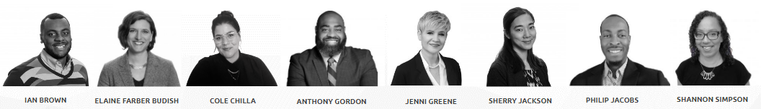

**Engagement and Commitment**

Please take a moment to review the Cultivating Community Framework (CONNECTION, CURIOSITY, COMPASSION, and COURAGE) as well as the Community Agreements. They serve as an integral part of building skills for racial equity conversations and for holding each other accountable during session breakouts and whole group discussions. 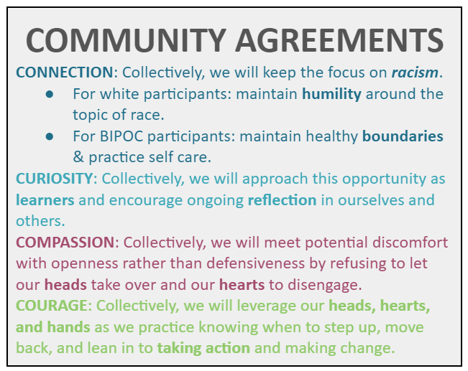

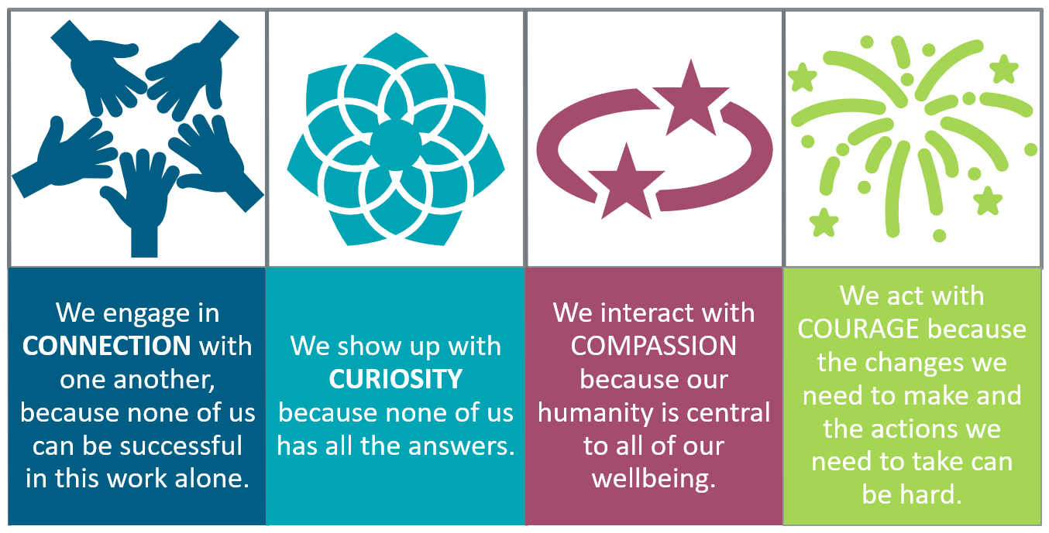

**Session Learning Objectives**

Consider each of the following learning objectives for our upcoming session as we view them through the Four Levels of Racism: Which are you CONNECTED to? Which are you CURIOUS about? Where will you need to tap into your COMPASSION or your COURAGE?

| **In this session, participants will be able to RECONNECT in the creation of liberated communities by:** |
| --- |
| * I will grow in my ability to navigate the challenging aspects of connecting across differences in radically human ways. **Individual** * We will explore how the Building Liberatory Communities tool can help us to avoid harm and align impact with intention in our racial equity work. **Interpersonal** * We will understand how a design justice approach to the work of organizational change is an antidote to dominant culture. **Institutional** * We will explore how the Liberatory Communities approach enables us to engage fully in the work of challenging dominant cultural norms and assumptions. **Structural** |

**Session Resources and Points to Ponder**

For each of the topics below, we have included select resources that will enable you to make the most of the upcoming ADEI learning session as well as questions to consider as you preview the resources. You can also access these resources and more in your **Participant Guide** on the [**ADEI Website**](http://www.adeitraining.com/) one week prior to the session. It contains all the materials and resources that will be used during the upcoming session.

| **Topic** | **Resources** | **Questions to Consider** |
| --- | --- | --- |
| Shared Language | **It is important to ground ourselves in a shared language and understanding. Therefore, please review:**   * [UPD’s ADEI Glossary](https://docs.google.com/document/d/1oSpNIt1_cgb-xsNBe4LQ9KNb4Deb8vqh4EeV43unSjs/edit?usp=sharing) (2 mins) | For this session, you may want to focus on:   * *Ally, Decolonization, Equity Detours, Justice, Liberation* * What terms were new to you? What would you add or modify? |
| Review Important Resources from Session #3 - DISCONNECT– Exploring Strategies to Engage in Productive Conversations About Race & Racial Equity | **The series builds throughout the sessions. Therefore, it is important to refresh yourself on the following that were used in the last session.** (5 mins to review all)   * [Four Zones of Proximal Growth](https://drive.google.com/file/d/11r8CSbyYwhMlXe2ciIjPfAW6kgyoedbS/view?usp=sharing) ***\*new at S#3*** * [Zones of Becoming Anti-Racist](https://drive.google.com/file/d/1qJF0xHnJg063Mopdwu4v1H4RHKkLekSS/view?usp=sharing) ***\*new at S#3***   ***Used in every session***   * [Cultivating Community](https://drive.google.com/file/d/1XUNpzQ4qIeK1dQOKp88DdYP0vrsypUkS/view?usp=sharing) * [Four Levels of Racism](https://drive.google.com/file/d/19mAP-jwPdmPzfL4TWWjxxORFRY9L1Mz1/view?usp=sharing) * [HEAD – HEART – HANDS](https://drive.google.com/file/d/1qcPNxYy-or_j8K7E6QTxT5kBMYe0AIBD/view?usp=sharing) * [Garden Analogy Graphic](https://drive.google.com/file/d/1X_y7wmyBEuAW0W_xyGCCw-HheEdEUi9A/view?usp=sharing) | **Content**   * *What content from Session #3 has remained in your mind or in your heart in the past few weeks?* You may find it helpful to review Session #3 materials linked here, located on the ADEI website, as well as the frameworks located to the left:   + [Session Slide Deck](https://drive.google.com/file/d/10B2o8uJmY9jjfkwQf0BkrZNB4roePoqM/view?usp=sharing)   + [Participant Guide](https://docs.google.com/document/d/18IN-GUJ-EcemBipZlgJJ6cMThDDSq3rVlU1HipVxxG4/copy#) * You will also be asked to recall an opportunity you had to “speak truth” in an area of racial equity. The following prompts may help you prepare to share out:   + Did you take “the leap”?   + Why or why not?   + What helped (or would have helped) you most in this conversation? *\*Think specifically about elements of the Cultivating Community Framework.* |
| Prepare for Session #4 - RECONNECT– exploring People-Centered Approaches to Addressing Barriers to Racial Equity and to Building Liberatory Communities | **Preview of Equity Detours** (5 mins)  We will explore and apply each of these concepts deeply in the session. Here is a preview of the definitions:   * **Equity Detours:** Equity detours are the actions and approaches organizations often adopt that might create the illusion of equity progress * **Pacing for Privilege:** a detour that prioritizes the comfort and interests of white people over actual progress towards racial equity. Moving at the pace of the people with the least interest in racial equity rather than the pace of the people with the most interest * **Deficit Ideology:** focusing equity efforts on programs, initiatives, or practices designed to adjust the mindsets, values, behaviors, or “grittiness” of BIPOCs while ignoring racial inequity. The focus is on “fixing” BIPOCs rather than redressing inequitable systems. Language is a common example of this | **Preview of Equity Detours**  We encourage you to share your personal and professional experiences and examples during the session. To help prepare, you may want to consider the following for each type of equity detour:  **Pacing for Privilege:**   * For **Educator** Participants: *When was a time that you were guilty of moving at the pace of privileged peoples’ comfort (either your own or others’)* * For **Student** Participants: *When was a time that you observed an educator, colleague, or friend move at the pace of those more privileged? How did the experience affect you?*   **Deficit Ideology:**   * For **Educator** Participants: *What are some examples that you have personally said or done (or observed other educators say or do)?* * For **Student** Participants: *What are some examples that you may have personally experienced in the classroom (or other educational setting)?* |
| **Special Request:** We encourage you to practice being brave and speaking from a first person point of view. Personal examples help us collectively build empathy and practice holding discomfort. Facilitators will be modeling this throughout the session. | |
| Bridge to Practice | **Each session introduces a Bridge to Practice that is meant to move the session learning into application.** (5 mins)   * Review the **Bridge to Application** activity and reflect on your implementation efforts. The activity can be found on page 13 of the [Session #3 Participant Guide](https://docs.google.com/document/d/18IN-GUJ-EcemBipZlgJJ6cMThDDSq3rVlU1HipVxxG4/copy#). *Note: this is a link to a forced copy. You may already have a digital copy of the guide with your personal notes saved. Please reference your saved copy if that is the case.* | You will be asked to **share a brief summary of your practice** and to **share your noticings and wonderings from your implementation** of your Bridge to Practice with colleagues. You can prepare ahead of time by thinking about the following:   * What you found rewarding and challenging about the activity? * Where did you notice as you explored the **PURPOSE**, **POWER** Dynamics, and **POSSIBILITIES** of your team’s prioritized racial equity challenge?   *\*NOTE: We are always responsive to your feedback. After Session #4, many of you asked for specific examples in the adult education context. We are excited to share a recorded conversation with one of the participating program teams at our upcoming session.*  *HUGE THANK YOU to* ***Suffolk Sheriff’s Education Department*** *for taking the time to sit down with UPD facilitators and discuss their thinking and initial planning in the selection of their racial equity challenge. This is definitely a moment you won’t want to miss and one you will undoubtedly find very helpful!* |